We need 3-6 posts that we will do on a rotating basis on Social Media Platforms. Please send us as per the below format:
- Short Text /Title (70-90 characters)
- #Tags:
- @Tags:
- Picture/Image:
- Link (will be from Chemical Market or a product uploaded on ChemicalMarket.net)

Sample1:
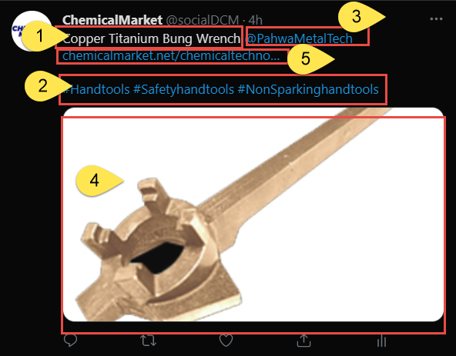

Sample2:
